
Teacher.José Wolney
COLÉGIO NOSSA SENHORA DA PIEDADE
Valor: ____
Aluno (a): ______________________________________ Nº _____

CRITÉRIOS AVALIATIVOS, INFORMAÇÕES E RESULTADO
9º ANO  Turma: “_____”  ____–____–____ | - Domínio e aprofundamento do conteúdo, organização e clareza das ideias;  - A interpretação das questões será considerada como item do critério avaliativo;  - As questões objetivas não devem ser rasuradas, caso ocorra não serão aceitas;  - Resolva as questões à caneta azul ou preta;  - Não utilize líquido corretivo.

Work in group (1,0) | Classmarker (1,0) | Continued Examination (1,0) | Exercises  (1,0) | PROVA  (6,0)

PROVA DE INGLÊS - (1st Unit)
1 – Read the text carefully and answer the questions bellow (1,0 – 0,2 each)

ONE FALL

MOVIE INFO
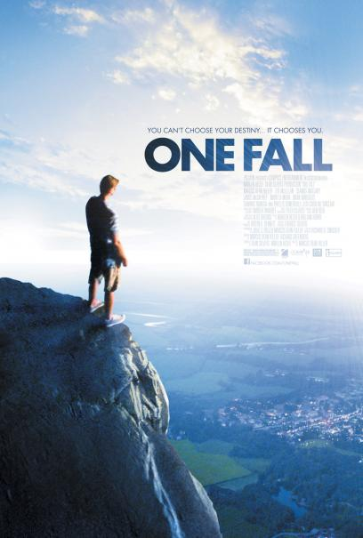
One Fall, a powerful story about a man (Marcus Dean Fuller) _1__ is both blessed and cursed with an unusual power, is set in the rustic Midwestern town of One Fall. The film tells the story of a man who miraculously survived a terrible fall from a spectacular 200 foot-high precipice that is the area's major attraction. After recovering, he abruptly abandoned friends and family and disappeared without explanation. The secret he couldn't share with them was that, while recovering, he had suddenly developed the power to heal others. Tired of running away, he returns home after a long absence and decides to use his gift - but not altruistically. If people pay him, he will cure them. Though he appears to be doing the right thing, he is doing it for all the wrong reasons, and risks driving away anyone that ever loved or trusted him. As his moral crisis peaks, he must figure out why he survived his fall, and what he is really meant to do with his life. -- (C) Paladin

PG-13, 2 hr.
Drama, Science Fiction & Fantasy
Directed By: Marcus Dean Fuller
Written By: Marcus Dean Fuller, Richard Greenberg
In Theaters: Sep 9, 2011 Limited
On DVD: Apr 2, 2012
Paladin Films - Official Site

Adapted from: < http://www.rottentomatoes.com/m/one_fall/> Acess in 12/03/2013

Both blessed and cursed = ao mesmo tempo amaldiçoado e abençodo
unusual = incomum
fall = queda
200 foot-high precipice = precipício de 200 metros
share = contar
heal = curar
running away = fugir
gift = dom
driving away = afastar
As his moral crisis peaks = em um momento de crise
must figure out = deve descobrir
meant = significado

1.1 – Replace the number 1 for the correct relative clause. Justify your answer.

1.2 – The movie ‘One Fall’ is:

a) rated as appropriate for audiences of all ages.
b) the story of a famous and popular spiritual healer.
c) starred, directed and written by the same person.
d) about a beautiful mountain that oversees the city.
e) also a play that will be staged from September 9 on.

1.3 – We can omit WHO in this sentence “man who miraculously survived a terrible fall”? Why? Justify your answer.

1.4 – From this movie review, one realizes that the film was named after

a) the name of a rustic town.
b) the reference to a terrible fall.
c) the main character’s complete name.
d) the description of an unusual power.
e) the indication of an area’s attraction.

1.5 – We can change THAT for another relative clause in this sentence “man who miraculously survived a terrible fall”? Why? Justify your answer.

2 – Observe the picture below. Write four (4) comparisons using different forms of comparison and the cues (adjectives) given. (1,0 – 0,25 each)

heavy – messy – old – fat – short – beautiful – thin – young – organized – tall – ugly
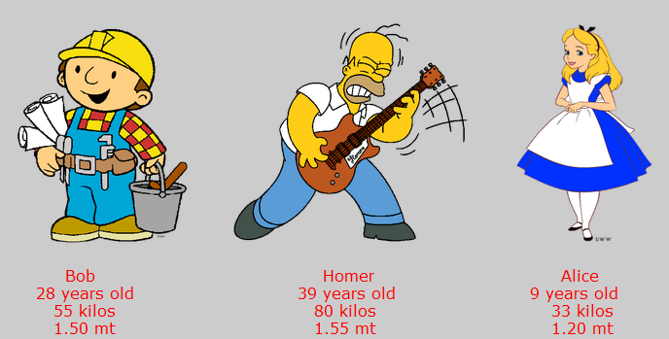

Equality - ___________________________________________________________________
Superiority - __________________________________________________________________
Superlative - _________________________________________________________________
Inferiority - ___________________________________________________________________

3 – Fill in the blanks with the suitable relative pronoun. Omit it whenever possible. Use all possiblites if it’s possible (1,0 – 0,2 each):
- The dress ________________________________________ Mary bought was very nice.
- Mrs. Smith ____________________________________ a senior teacher has retired now.
- The car _____________________________________ Fred bought last year was a BMW.
- I know a girl ________________________________ goes camping in Austria every year.
- That’s the man _________________________________________ dg run away yesterday.
4 – Read the situations and complete the sentences. Use be or get used to (1,0 – 0,2 each)

- Juan is Spanish and came to live in England. In Spain he always had dinner late in the evening, but in England dinner was at 6 o'clock. This was very early for him. When Juan first came to England, he _____________________________ (have) dinner so early, but after some time he got used to it. Now he finds it quite normal. He ___________________________________ (have) at six o'clock.
- Julia is a nurse. A year ago she started working nights. At first she found it hard. At first Julia didn't like it. She ________________________ (work) nights and it took her a few months to ______________________ it. Now, after a year, she's quite happy. She ___________________ (work0nights.

5 – Past Continuous or Simple Past ( 1,0 – 0,125 each)
a) Megan ____________________________(have) fun with her friends when a strange object ____________________ (appear) in the sky.
b) The object____________________________ (become) red while the people __________________________________ (watch) it.
c) When the UFO ____________________________ (disappear), it ________________________________(fly) fast.
d) Nobody___________________ (can) explain it because they _________________ (have) an astonishing experience.

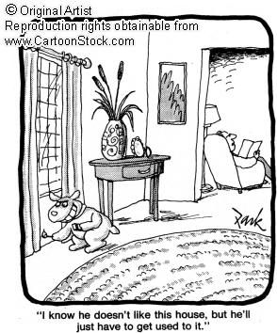
6 – Questões Vestibulares (1,0 – 0,25 each)

6.1 – There __________ be a drugstore on the corner of this street. Now there’s a supermarket

a) is used to
b) used to
c) are used to
d) get used to
e) N.D.A

e) N.D.A

6.2 – I cut my finger when I ________________________ the dishes.

a) washed
b) was washing
c) wash
d) 1 and 3 are right
e) 1 and 2 are right

6.3 – This is the bedroom _____________ he was murdered in

- Who / that / Ø
- Who / that
- Which / that
- Which / that / Ø
- N.D.A

6.4 – Adjetivos curtos fazem comparação de Superioridade acrescentando ER ao final. E se terminar em CVC dobra a ultima consoante e acrescenta ER. A EXCEÇÂO a esta regra é

a) THIN
b) NEW
c) BEAUTIFUL
d) FAST
e) MAN

Good Luck!

