


READ ABOUT PEOPLE’S PROBLEMS
- Elizabeht is bored.
- Katherine is very busy. She has to wash a lot of clothes.
- Tommy is in love. Alice loves Tommy.
- Ruth is worried. Her mother is ill in bed.
- Carol is angry with her mother.

CHOOSE THE SUITABLE ADVICE FOR THESE PEOPLE
1.- She should talk to her mother
2.- They should go out together.
3.- She should phone a friend and go to the cinema.
4.- She should call the doctor and give her some medicine.
5.-She should buy her a washing machine.

GIVING ADVICE





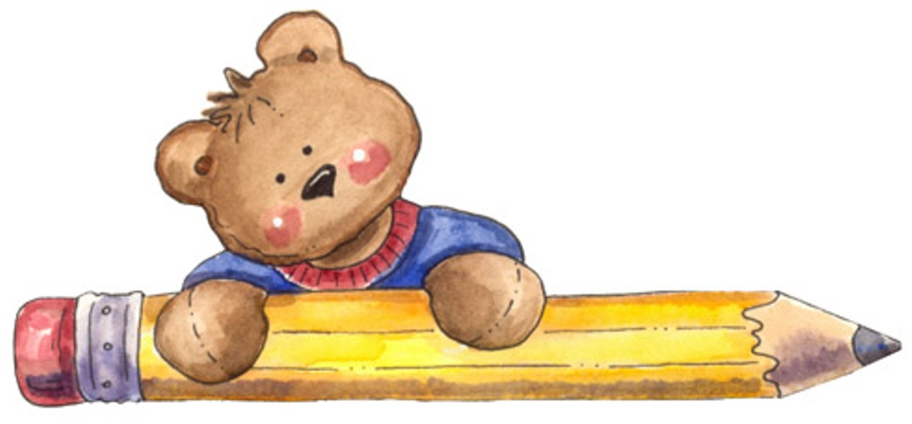
R
COMPLETE THE FOLLOWING SENTENCES GIVING ADVICE
1.- If you want to improve your English, you should……………. English videos, films and TV programmes.
2.- You should ……...... better if you didn’t smoke so much.
3.- You should …………….. eight hours a day.
4.- You are getting a bit fat, you ………….. eat more vegetables.
5.-If you want to go on holiday, you …………. some money every day.
6.-Don’t throw papers on the floor. You should ………. them in the basket.
7.-Your sister is late for work. She should ……….. to bed earlier.

