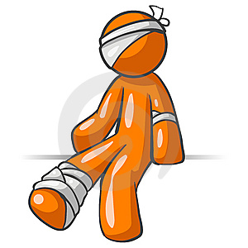
Giving advice

Instructions: read the following situations and give an appropriate
advice for each using “you should….”.

Situation 1

Patient: “Doctor, I’m feeling sick, I don’t want to get worse! What can I do?”
Doctor: Well, if I were you, I’d stay at home and ´have some rest.

Situation 2

Sarah: Jonathan, I have fever, tell me what to do.

Jonathan: ___________________________________________________________________________

Situation 3

Daughter: Mom, mom!!! Billy is bleeding, what should I do?

Mom: ________________________________________________________________________________

Situation 4

Mark: Doctor, my arm hurts a lot; I think I might have a fracture!

Doctor: ________________________________________________________________________________

Situation 5

Husband: Honey, my migraine has back!

Wife: __________________________________________________________________________________

Situation 6

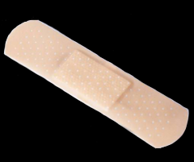
Patient: Please help me doctor, my girlfriend has a extreme diarrhea. And she is not happy about it.

Doctor: _______________________________________________________________________________

GIVING ADVICE II
- I want to quit smoking. What should I do?
- I won 100,000 dollars and I don't know how to spend it. What should I do?
- I gained a lot of weight in last few years. I want to lose at least 10kg. What should I do?
- I have just lost my job. I haven't told my husband/wife yet. How should I tell him/her?
- I found a wallet which had 2,000 dollars in it. Should I spend it?
- My son doesn't want to go to school. He says that his teacher and all other students hate him. What should I do?
- My child wakes up very often in the middle of the night. He sleeps usually during the day. I haven't had any good sleep for weeks. What should I do?
- I have a headache. What should I do?
- I hate working. What should I do?
- I feel sad. What should I do?
- I am always late. What should I do?
- I keep losing my credit card. What should I do?
- I have a cold. What should I do?
- I am new in this city. I would love to meet some people. What should I do?
- I want to get rich quickly. What should I do?
- I need a car but I don't have enough money. What should I do?
- My girlfriend left me. I feel depressed. What should I do?
- My husband doesn't help me with the house work. What should I do?
- My wife criticises me all the time. What should I do?
- I need to find a job. What should I do?
- I need to learn English much faster. What should I do?
- My girlfriend/boyfriend is seeing another man/woman. I saw a message in his/her mobile phone. What should I do?
- I hate my body. Should I have plastic surgery?
- I want to travel. Should I get a job abroad? Where?
- I hate cooking. What should I do?
- I want to live as long as possible. What should I do?

