Complete the sentences with SHOULD or SHOULDN’T
recycle rubbish−hurry up− tidy your room− study more− eat sweets− wear glasses −fight –use the cellphone
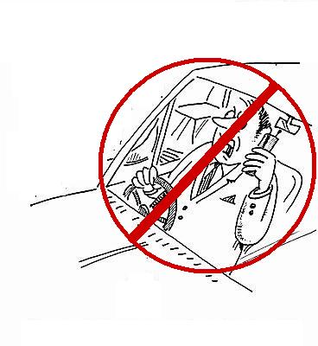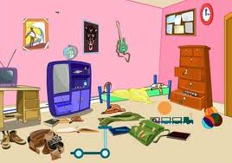
1……………………………………………………. 2……………………………………….…………….…. 3…………………………………………………………
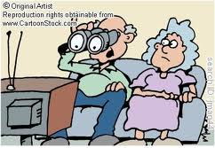
4………………………………………………………… 5…………………………………………………..… 6…………………………………………………
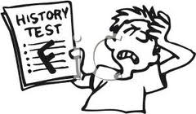7………………………………………………………… 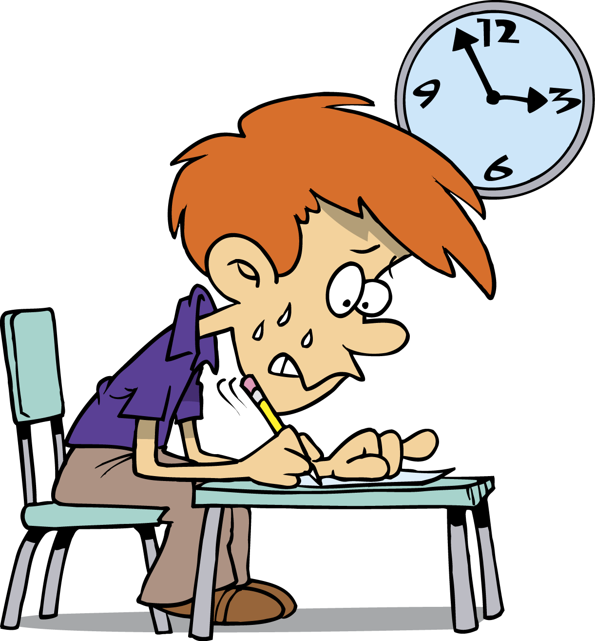8…………………………………………………………

Complete the sentences with SHOULD or SHOULDN’T
recycle rubbish−hurry up− tidy your room− study more− eat sweets− wear glasses −fight –use the cellphone
1……………………………………………………. 2……………………………………….…………….…. 3…………………………………………………………
4………………………………………………………… 5…………………………………………………..… 6…………………………………………………
7………………………………………………………… 8…………………………………………………………

