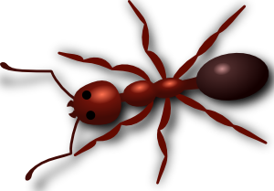
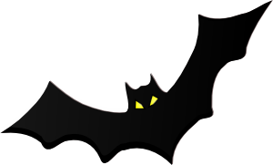
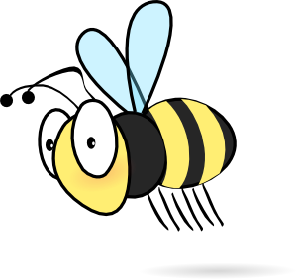
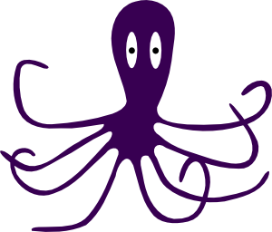
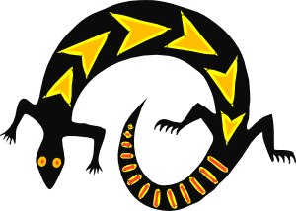
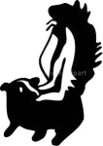
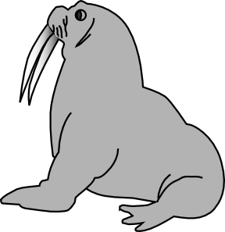
Problems...
Advice
needed
Go
Home
37.
The weather is hot and sunny.
63. I get homesick when I’m away on holiday.

64. I want to
help fight against climate change.

65.
I want to marry a millionaire.
60.
I got fired
from my job.
59.
My English isn’t very good.
58. I’m
thirsty and
the fridge
is empty.
55.
I’m
depressed.
56.
I have
chest pains.
57.
I’m broke.
51.
I often
get carsick and seasick.
52.
Someone stole my wallet.
53.
I’m feeling lonely.
48. I had a
car accident.
It was
my fault.
47.
I’m starving.
46.
I want to
lose weight.
41.
I lost
my keys.
42.
A bully stole my lunch money.

43. I shot
a burglar
in my house
last night.
38.
I’m always
late.
39.
I’m worried
that I’m
HIV positive.
40.
I’m in love
with Beyoncé.
44.
The weather is cold and rainy.
62. I got
detention because I was late.

61. I’ve got
only six
months
to live.
50. I got
into a fight
at school yesterday.
36. I got hit
by a car
while crossing
the street.
35.
I’m
exhausted.

34.
I want to be rich.
32.
I got bitten
by a snake.
31. I’m bored
when I have
a lot of
free time.

30.
I hate
my job.
25.
I think my wife has an affair.
26. An alien spaceship landed in my garden.
27. I think
my boyfriend
is cheating
on me.
13. It’s my
mother’s birthday tomorrow.
14.
I got lost
in the desert.
15. My left
eye hurts
when I drink coffee.
1. My car
broke down
on the motorway.
2.
I have a headache.
3. I think my parents hate me. We don’t get along.
9.
I’ve booked a trip to Egypt.
10.
I’m allergic to cats and dogs.
11. There’s
no water or electricity in the house.
22.
My girlfriend dumped me.
18. I’ve got
a bad case
of agoraphobia.
17.
I think
I’m ugly.
16.
My landlord kicked me out.
21.
I’m fat.
20. I’ve got
a bad case of claustrophobia.
19.
I can’t swim.
6.
I failed my English exam.
5.
I can’t sleep
at night.
4.
I’m going
on holiday
to London.
8.
My father’s in hospital.
7.
A stray dog
bit me.
23. I don’t
know what to do after secondary school.
28.
I stepped on a rusty nail.
12.
24.
28.
49.
45.
54.
33.
12.
How to play
- Players give advice using appropriate language (see p.2).
- The number of pieces of advice needed to continue should depend on the level of players (e.g. Elem. 2, Pre-int. 3, Interm. 4., Upper-int. 5, Adv. 6).
Moving
- Players go from top to bottom choosing their own path starting from Go and flip a coin (heads = 1 move, tails = 2 moves). or
- They can roll a die and follow the numbered squares, losing a turn on the Danger squares.

Ways to give advice
Warning!
Squares 25, 27, 39 and 40 might be inappropriate because of cultural differences or students’ age.
Please replace with other problems if needed.

- You should/ shouldn’t + infinitive
- You should have, shouldn’t have + past participle
- You ought to + infinitive (formal)
- It would be a good idea if you + past simple
- If I were you, I would ...
- You had better ... + infinitive
- You will have to + infinitive
- It is time you + past simple
- Why don't you ... + infinitive
- You could always ... + infinitive
- Have you thought about ... + ing
- Imperatives (don't ... Do ...)

Sample answers – Students should use their imagination; create and funny answers should be rewarded.

- You should have your car serviced more regularly. You should buy a new car. You should get AA/breakdown cover. You should buy a new car. You should have called me to come and get you. It would be a good idea if you got rid of that clunker.
- You should take a break. Why don’t you take some painkillers? Go for a medical check-up. You shouldn’t sit on front of your computer/TV for so long.
- You should talk to them. You shouldn’t keep this to yourself. Why don’t you talk to them? You could call a helpline. You shouldn’t think of murdering them.
- You shouldn’t miss the Tower of London. You should go to the Natural History Museum. You should go see the Changing of the Guards. Why don’t you take a side-trip to Oxford?
- You should do some exercise in the evening. You could always take a sleeping pill. You should get medical advice. You shouldn’t drink coffee in the evening.
- You should have studied harder. You should take English more seriously. You should have practiced more. You should have asked for help. You should have taken a trip to England. Try to find a penfriend/penpal/keypal.
- You should go to the doctor’s. You should get a rabies shot. You should have run harder. You should carry pepper spray. Why didn’t you hit it with your umbrella?
- You should visit him. Why don’t you give him a call? You ought to speak to his doctor. You should help your mother at home. Don’t worry; I’m sure he’ll be okay.
- You should have told me; I could’ve gone with you. Don’t miss the pyramids. You should take light, cotton clothing. Don’t forget your sunscreen. You should go for a camel ride. You had better not try to flirt with local women.
- Get yourself another pet then. You shouldn’t go near them. You could always get a Robodog (robotic dog). You should find a flat in a building where pets aren’t allowed. You should carry a long stick to keep dogs at bay.
- You should check the fuse box. You should phone your landlord. You should pay your utility bills on time. Why don’t you use the neighbour’s shower? You could always use candles and go unwashed.
- (octopus)
- You should get her a nice present. Why don’t you give her a phone call? You should take her out to a nice restaurant. You shouldn’t drop off your laundry tomorrow then.
- You shouldn’t have gone there in the first place. You should have taken a sat phone with you. Why didn’t you take a local guide with you? You should know better than to venture out there on your own.
- Don’t drink coffee then. If I were you, I’d ask some medical advice. You should see a doctor about this. You should send your story to the ‘Bizarre but true’ section of the local newspaper. It would be a good idea if you removed the spoon before you drink.
- You should’ve paid the rent on me. You should sue him. You should kick up a fuss. Why don’t you become a squatter? You could always live under a bridge. Why don’t you start looking for some cardboard boxes?
- Don’t look in the mirror then. Get a nose job. You shouldn’t be so worried about your appearance; it’s the inside that matters. Why don’t you join a self-help club? You should see a shrink. You shouldn’t think like that.
- (Agoraphobia: fear of large open spaces such as malls, airports, etc.) Don’t go to Tiananmen Square then. You should get professional advice. Why don’t you get some hypnotic treatment? You shouldn’t be afraid of empty spaces. You could always wear a blindfold so you can’t see where you are.
- You should take swimming lessons. You shouldn’t go in the deep end of the pool. Don’t go swimming in the sea. Why don’t you go the mountains? You could always get a note from your parents so you can skip PE.
- (Claustrophobia: fear of being trapped without escape, often in small places) You shouldn’t use lifts. Why don’t you use the stairs instead of the elevator? Buy clothes without trying them on. Why don’t you try on new clothes in the middle of the shop instead of using the changing rooms? You should get professional help. You should go into therapy.
- Why don’t you go on a diet? Why don’t you try to lose some weight? Stop eating snacks between meals. Get your stomach stapled. Stop whining. You should eat more fruit. You shouldn’t eat so much candy. You should get some exercise.
- You should find another one. You shouldn’t sit around moping; there are plenty of fish in the sea. Why don’t you socialize a bit more? You could always register with an online dating service. Why don’t you order a mail-order bride?
- You should talk to a study advisor. You shouldn’t make rash decisions. You should think it over. You should sleep on it. Why don’t you ask your parents what they think? Why don’t you study (…)?
- (-)
- You should talk to her about this. You should tell her how you feel. Why don’t you hire a private investigator? You should see your lawyer? Why don’t you have her followed? You shouldn’t think like that; it could be innocent. It is time you started facing facts.
- etc…

I ran out of steam here. I hope you can come up with some decent advice yourselves.

